Available Luxary Vehicles

* **Land Rover Range Rover Sport Diesel 2.0L HSE**

Year of Manufacture - 2019

Mileage - 22,000 KM’s Done

Registration Number - CBM - XXXX

Spec - Panoramic Sunroof

Lane Departure

Digital Display

Deployable Foot Steps

Electric Tailgate

Dual side electric and memory seats

Meridian Surrounding Sound System

For more information call us

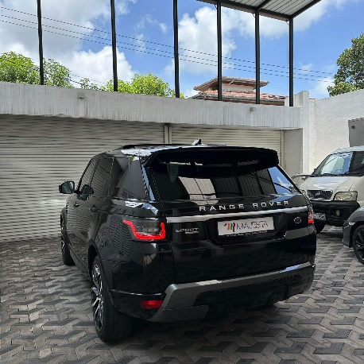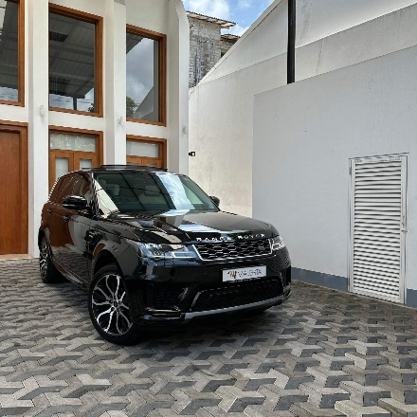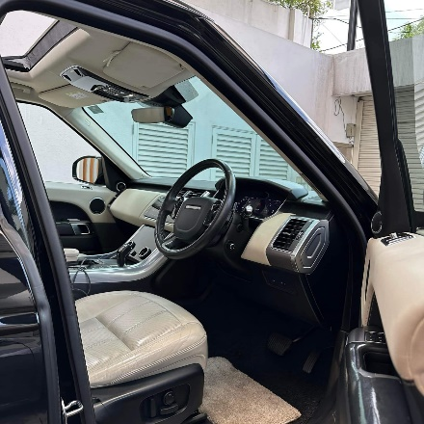

* **BMW 740LE M Sport 2018.**

M Sports package

63,000 KM’s Done

4 Seater

Soft Close Automatic doors

Surround View Camera

Bowers & Wilkins Surround Sound system

Panoramic glass Sunroof

Panorama glass roof 'Sky Lounge”

BMW Gesture Recognition

Ambient Interior lighting For more information call us

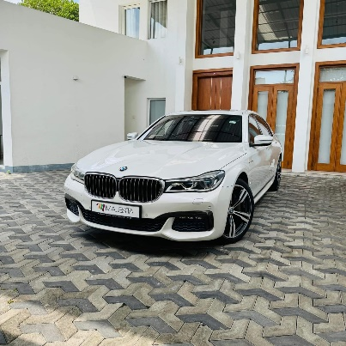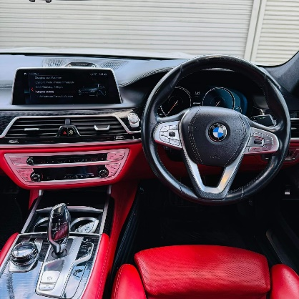 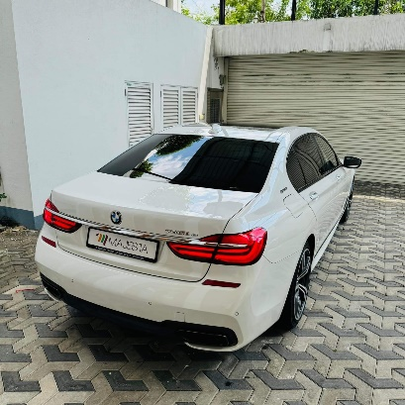

* **Mercedes Benz C200 AMG PREMIUM PLUS 2018**

Fully loaded Spec !

Hyacinth Red Exterior

Saddle Brown Exclusive Leather Interior

Airmatic Suspension

Driving Assistant plus

28,000 KM done

1500cc Turbo

Keyless Go comfort-package

AMG 19” alloy wheels

Park-Pilot with 360° camera

Traffic Sign Assist

For more informations call us

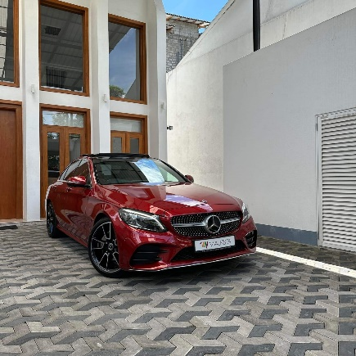 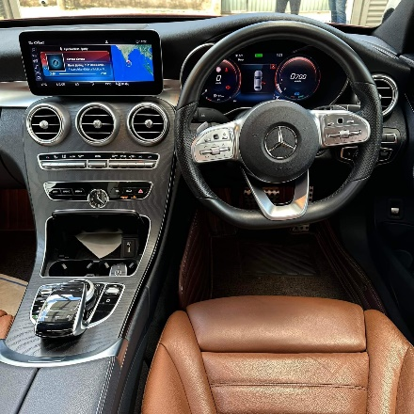 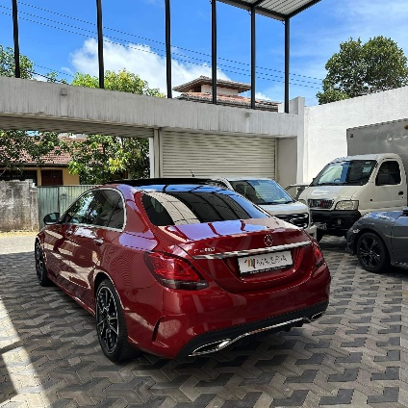

* Jaguar F Type P300 2018.

CBI-XXXX

Fuji White Exterior

Only 12,000KM done !!

Agents Brand New import With Comprehensive Warranty

Meridian soundsystem

Apple CarPlay

Electric seats

Jaguar LED technology head lights

20”Jaguar alloys

Carbon fiber exterior trims

For more informations call us

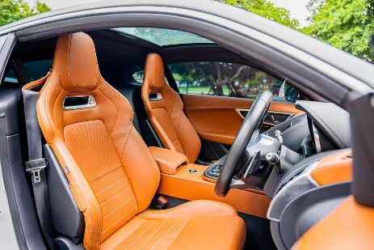 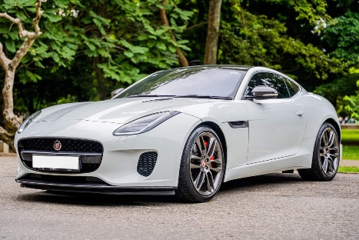 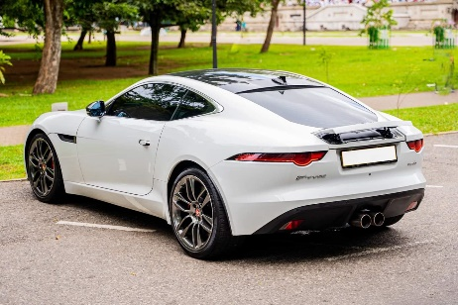

* **Toyota Land Cruiser Sahara V8 URJ 202**

YOM - 2018

Petrol - 4600cc

Mileage - 46,000 KM’s Done (Toyota Lanka Maintained)

CBE-XXXX

Spec –

Pearl White Exterior

Sliding Sunroof

Live surrounding Sound system

Cool Box

Teak Steering wheel

Cruise Control / Crawl control

7 Seater

Parking Sensors

For more informations call us

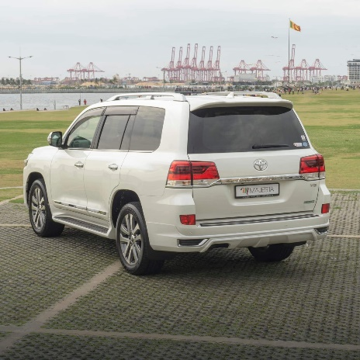 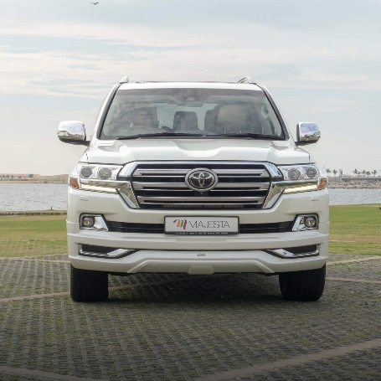 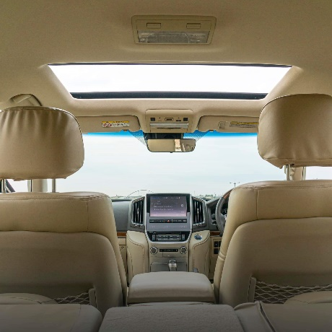

* **Audi Q2 2018**

1st owner

32,000 KM’s Done ( Drive-one Maintained )

Leather seats

Sunroof

Power boot

Flat bottom steering wheel

19 “ inch Alloy Wheels

Bang & Olufsen Sound System

Ambient Lighting interior

Fully loaded Company Imported Jeep !

For more informations call us

